The 8 × 68 S cartridge: born for deer, excellent in many other situations

A noblewoman never puts herself too much in sight and so it happens for the 8x68S cartridge which in recent years has given up some ground towards much more advertised US products.
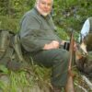 Emmanuel Tabasso

November 11, 2016Hunting in evidenceAmmunition and Hunting Powders
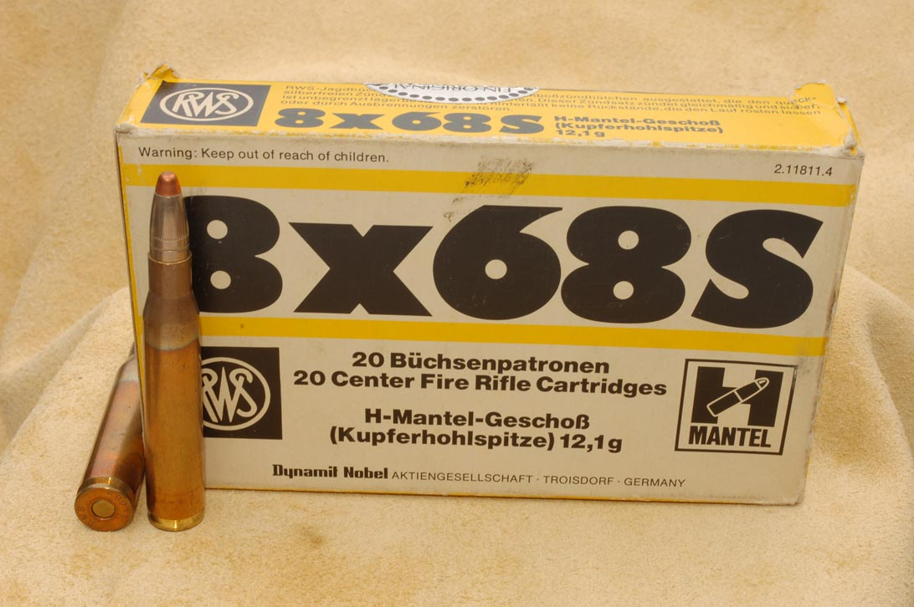The box of these 8x68S RWS is several years old, but we confirm that the ballistic result of the cartridges contained remains perfectly up to expectations
Officially born in 1940 with the studies of the engineer Otto Schuler, the 8x68S cartridge is set up with the main purpose of deer hunting in the German forests, in the Danube plains, in the woods and in the Carpathian mountains where specimens around three hundred kg in weight and trophies imposing illustrate the talent of the hunter, his weapons and the territory. Another 8 mm were already in use, the size considered specific for the king of the forest, such as the 8 × 57 and 8 × 60 by Mauser, together with the hefty 8 × 64 by Brenneke, all proposed in the normal or S version which indicates 8,2mm ball instead of the older 8,02mm ball. The new creation was born and remained only in the S version, as the suffix affixed to the canonical bullet and case sizes indicates. The aims of the project were soon said: a cartridge capable of pushing medium-heavy bullets, indicatively from 11,5 to 14,5 g, at unusual speeds for the time, therefore capable of ensuring a high trajectory voltage and a conspicuous reserve. of energy even at considerable distances, at the time quantifiable in 300 m, without neglecting the due accuracy. It should not be forgotten that in the period Germany was at the top in science and technology, including the guns, hence the idea of ​​accelerating a 12,7 g bullet, the most characteristic measure, just under 1.000 m / sec. it had turned into reality. If we observe the cartridge case we will notice some differences from the latest current creations and a reconfirmation: the latter is represented by the smooth body, without a belt, to which the Germans have always been fond, with the sole exception of the 7 × 73 Vom Hofe, because it guarantees a more precise position thanks to the much shorter space between the hit made by the shoulder and the position of the bullet than that given by the hit on the belt.
All the cartridges today, and in particular those for medium or long distance shooting, even in the United States, are structured as follows, and see in this regard the .338 Lapua Mag., The 6 XC, the 6 PPC, the 6,5 Creedmor, the 6,5 Grendel along with the Winchester and Remington short magnum series. The differences reside in the relationship between length and diameter of the body, it shortens and widens, and in the decidedly more pronounced angle of the shoulder, making better use of powders even a little more lively. Relying on high pressures remains a constant because the Schuler cartridge already hangs around 4400 atm: the slightly tapered body responds to the need for a greater volume in length and, together with the slope of the shoulder, to dilute a little, but precisely little, the dry and decisive recoil that comes from a charge of, for example, 78,0 g of MRP with a 200 g Nosler Partition bullet, Federal 215 M. trigger which, in a 70 cm barrel, comes out at 935 m / sec with 577 kgm, or from a less aggressive one, always with RWS case, 73,7 gr of N / 160 with RPM trigger, 195 gr Hornady SP bullet, 86,7 mm OAL, V / 0 in the 65 cm barrel equal to 900 m / sec with 522 kgm of E / 0 (without our responsibility or guarantee). Shooting with rifles of a few decades ago as an excellent product of the unforgotten Casartelli or a classic Mauser Europa 66, without muzzle brake of course, the results are assured both on the prey and on the hunter to whom the shoulder will give some pain for a few days. . However, the satisfaction will be great in mastering such a cartridge which, even in the shooting range, will show considerable consistency and precision.
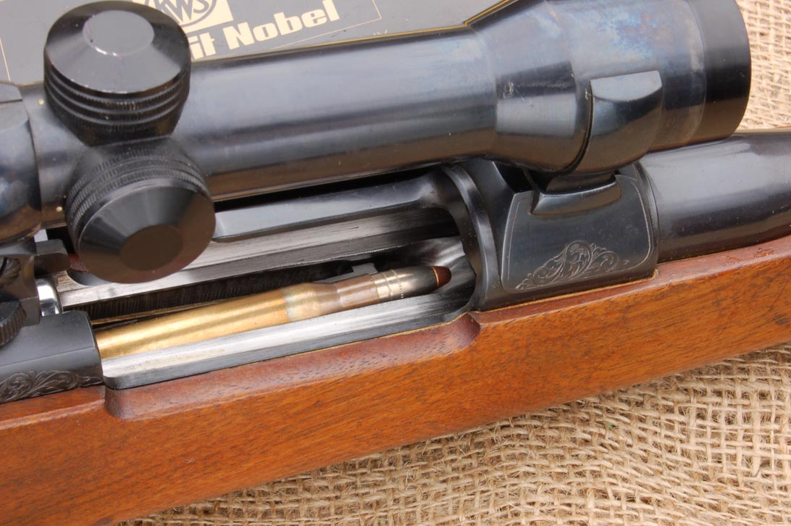The cartridge is inserted in the fixed magazine, ready to be chambered: it is a RWS with 12,1 g H-Mantel bullet used for a long time on deer before the latest novelties recently arrived on the market, still today it proves to be a guessed choice
On the ground it is more than ever necessary to choose a ball suitable for the wild: for light animals, a bit of everything is fine as long as the ball is not too fragile, damaging the body a lot, but for the deer, especially male, a ball like the one mentioned above. , the always excellent Brenneke TUG, the new RWS achievements such as the EVO ball guarantee the hydrodynamic shock, the correct penetration and the due release of energy for an immediate stop of the superb wild. The use in Africa has always guaranteed great satisfaction especially with the 14,5 g ball, the famous Torpedo Stopring, with which, from a convenient distance, the buffalo is landed with a precise blow to the neck on the spine, or the KS from 225 g; on the big antelopes then we proceed without any difficulty whatsoever. A medium-caliber cartridge that truly deserves the appeal of the queen of European achievements.

